**Tableau Functions**

Basic Usage of ENDSWITH

Suppose you have a field called [Product Name] and you want to check if the product names end with the word "Pro."

tableau

syntax: -- ENDSWITH([Product Name], "Pro")

* If [Product Name] is "Laptop Pro", the result will be TRUE.
* If [Product Name] is "Laptop", the result will be FALSE.

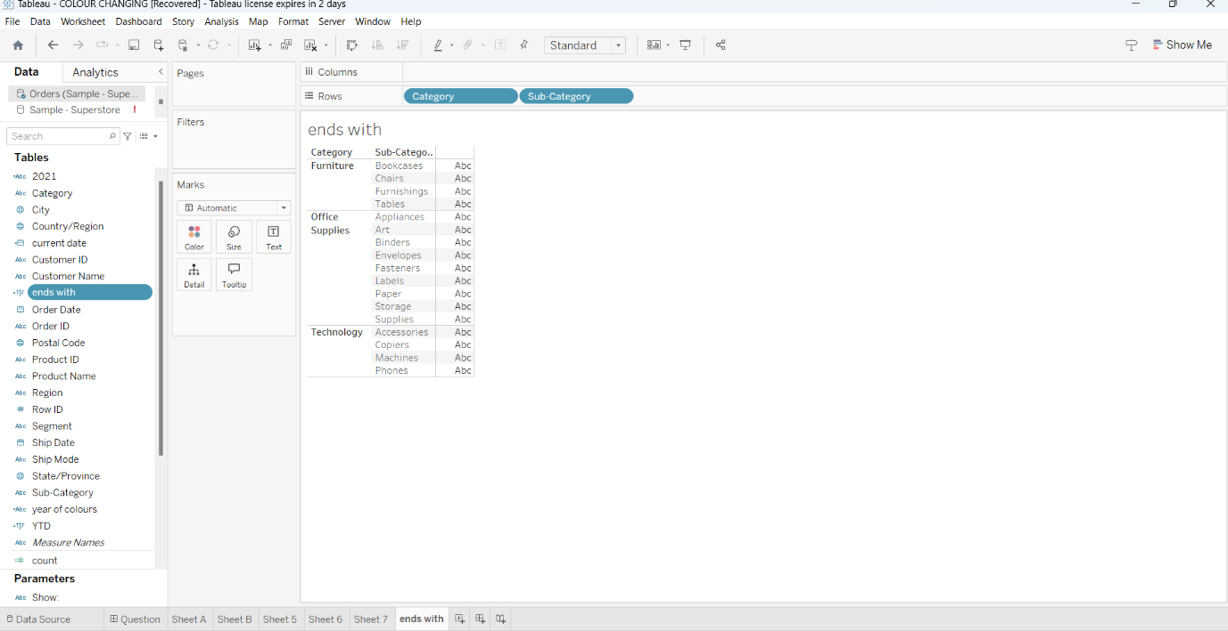

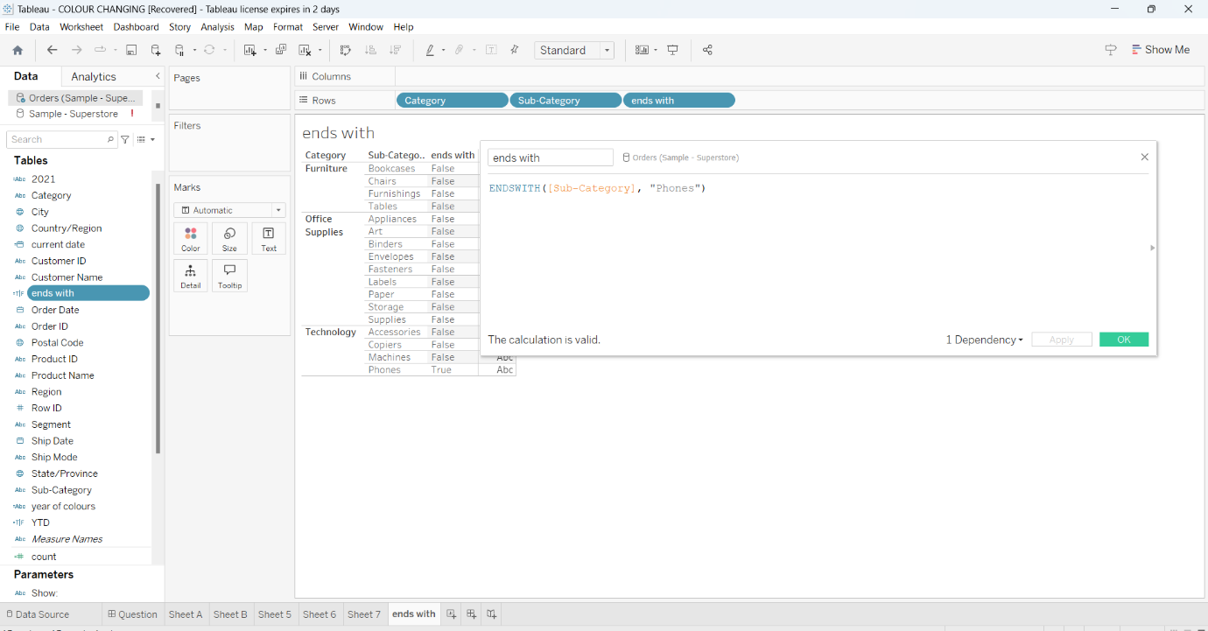

Basic Usage of LEFT

Suppose you have a field called [Product Code] and you want to extract the first 3 characters of the product code.

tableau

Copy code

Syntax: -- LEFT([Product Code], 3)

* If [Product Code] is "ABC123", the result will be "ABC".
* If [Product Code] is "XYZ456", the result will be "XYZ".

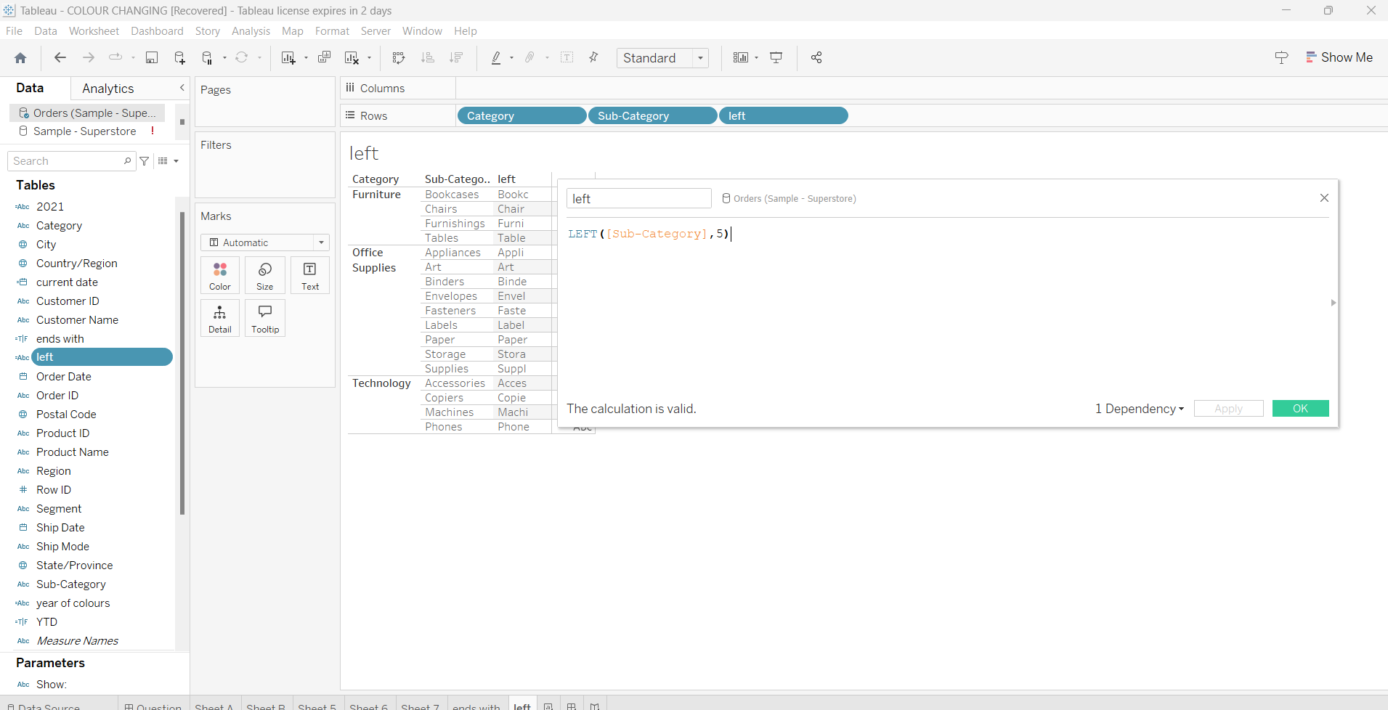

**Right function: --**

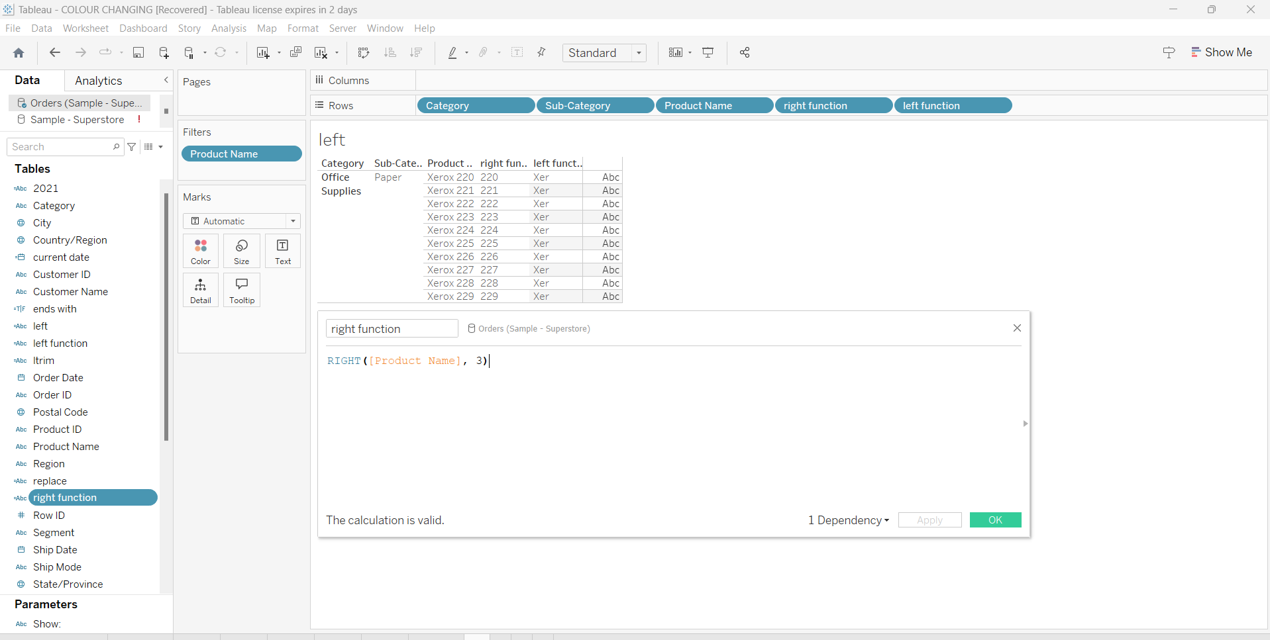

Basic Usage of LTRIM

Suppose you have a field called [Product Name] and it contains product names with leading spaces that you want to remove.

**Example:**

If [Product Name] is " Laptop", applying LTRIM would remove the leading spaces.

LTRIM ([Product Name])

* Input: " Laptop"
* Output: "Laptop"

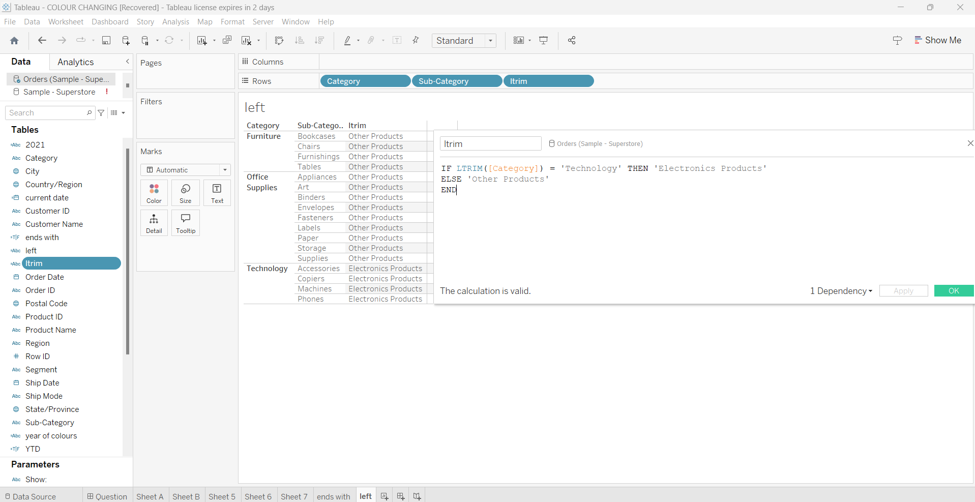

**Replace: --**

In Tableau, the REPLACE function is used to replace a substring within a string with another substring. This can be useful for cleaning data, modifying text, or performing string replacements.

**Syntax:** REPLACE(string, old_substring, new_ substring)

* **string**: The original string where you want to perform the replacement.
* **old_substring**: The substring that you want to replace.
* **new_substring**: The substring you want to use as the replacement.

**Example 1: Basic Usage of REPLACE**

Suppose you have a field called [Product Name] and you want to replace the word "Old" with "New" in all product names.

**Example:**

REPLACE([Product Name], "Old", "New")

* If [Product Name] is "Old Laptop", the result will be "New Laptop".
* If [Product Name] is "Old Smartphone", the result will be "New Smartphone".
* If [Product Name] is "Tablet", the result will remain "Tablet" because "Old" is not present.

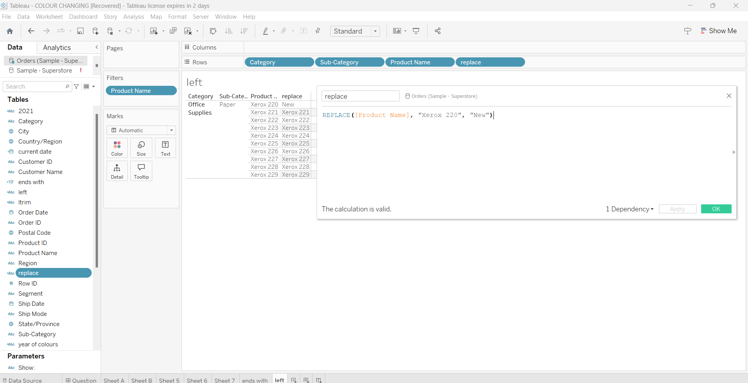

**Extracting the First Name**

You can split the full name by the space (" ") and get the first part (first name).

Syntax: --- SPLIT([Full Name], " ", 1)

SPLIT([Full Name], " ", 2)

SPLIT([Address], ",", 1)

SPLIT([Order Date], "-", 1)

* If [Full Name] is "John Doe", the result will be "John".
* If [Full Name] is "Jane Smith", the result will be "Jane".

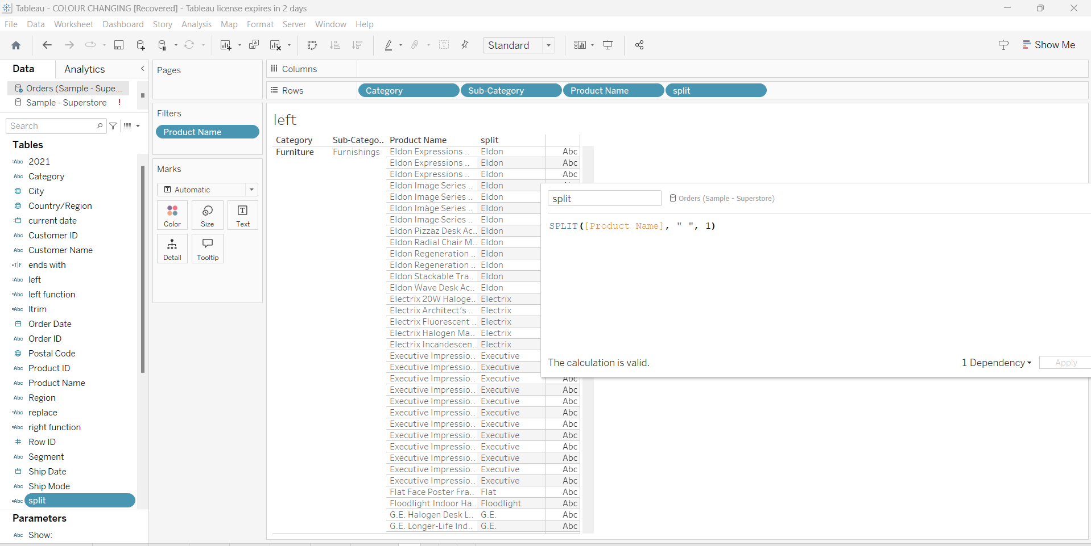

Basic Usage of STARTSWITH

Suppose you have a field called [Product Name] and you want to find all products that start with the word "Smart".

STARTSWITH([Product Name], "Smart")

* If [Product Name] is "Smartphone", the result will be TRUE.
* If [Product Name] is "Smart Watch", the result will be TRUE.
* If [Product Name] is "Tablet", the result will be FALSE.

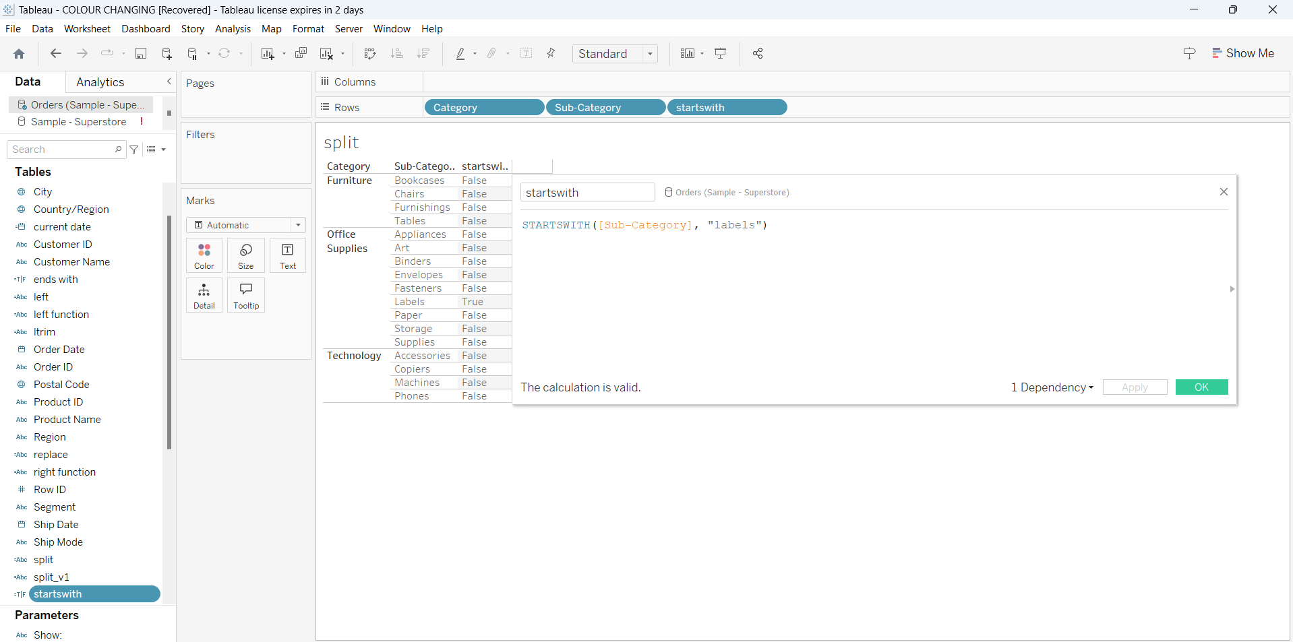

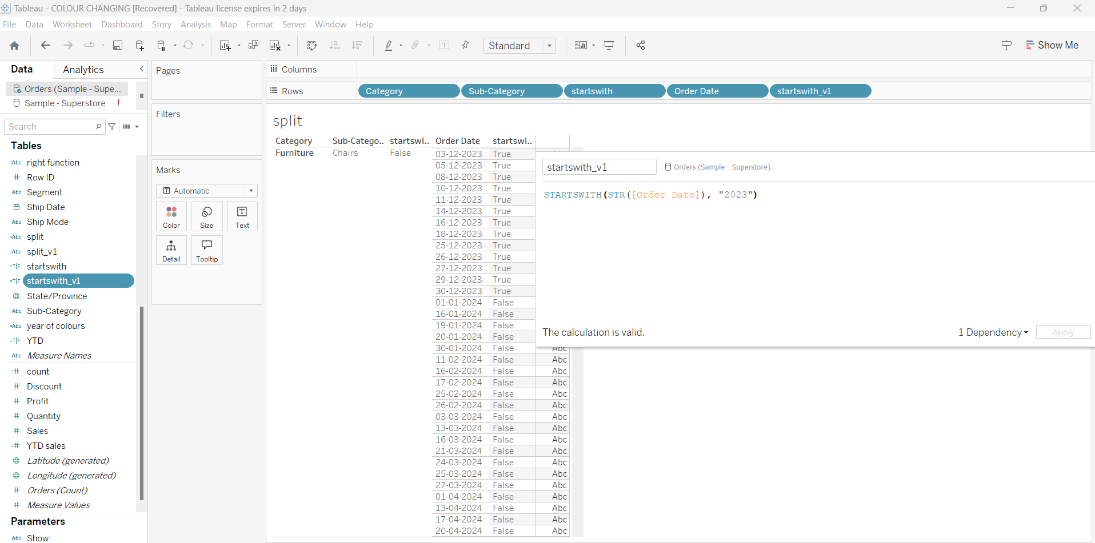

**Round function: --**

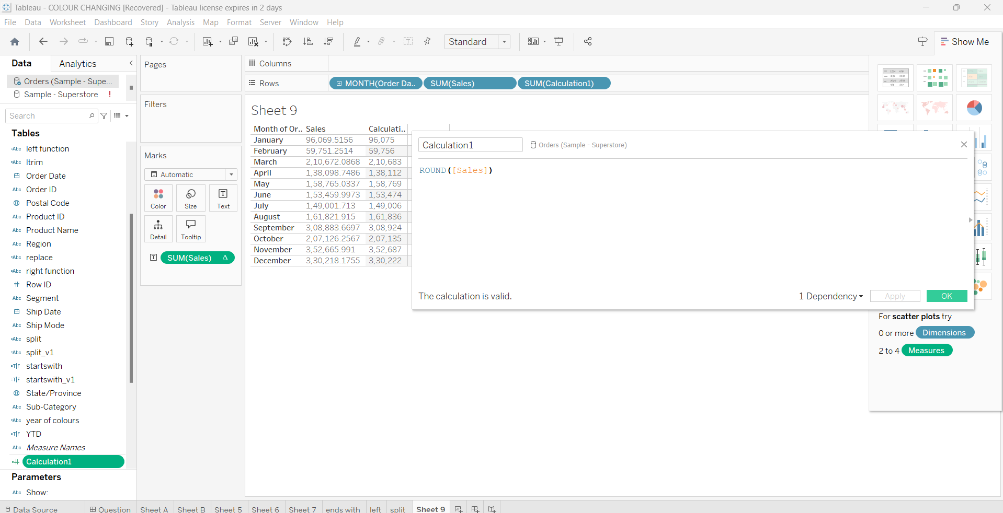

**Isnull (): --**

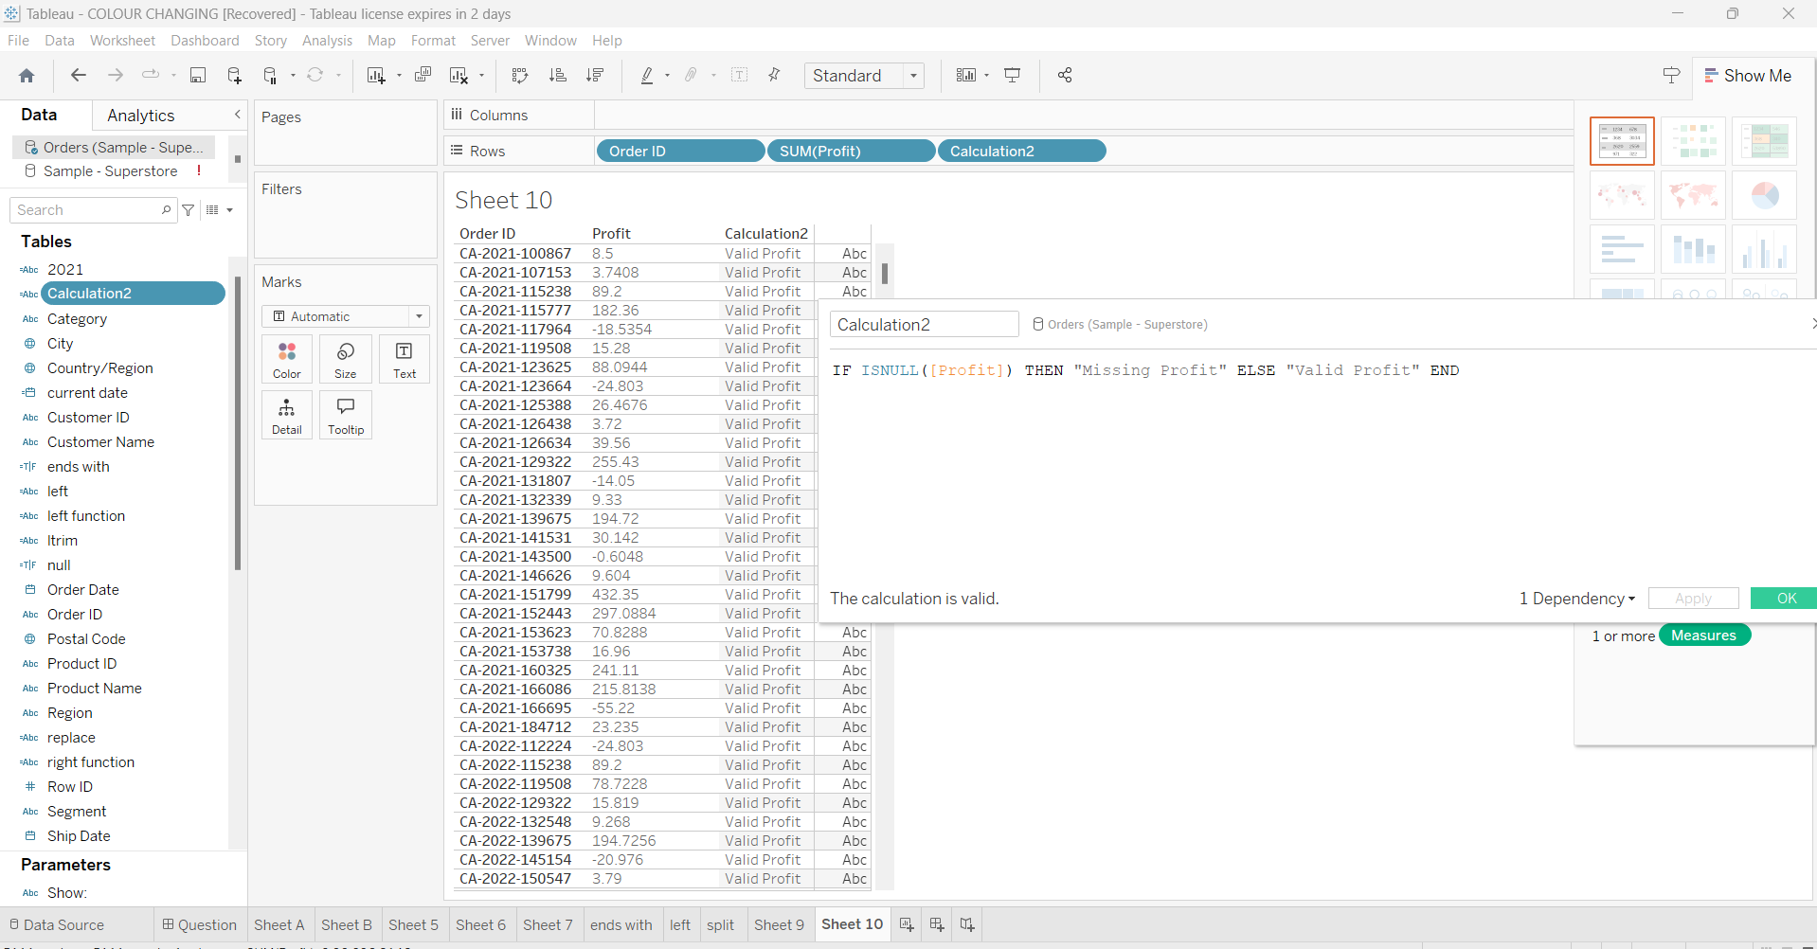

**Controllers: --**

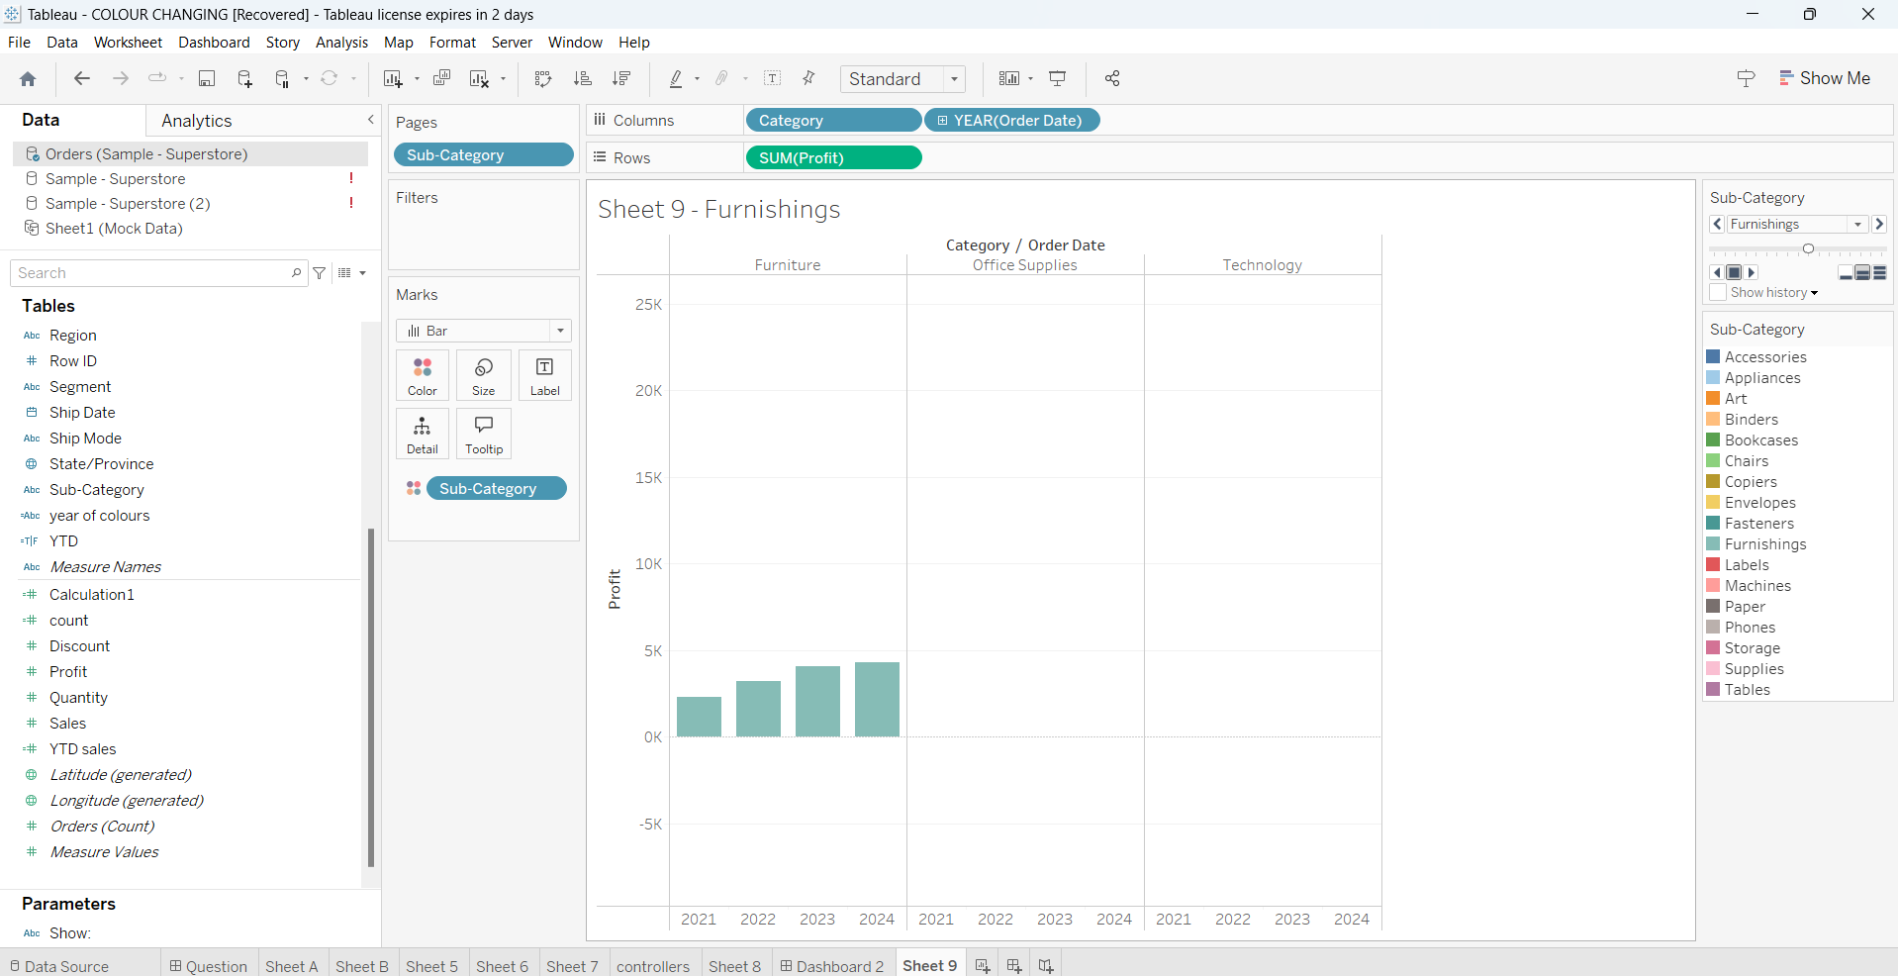

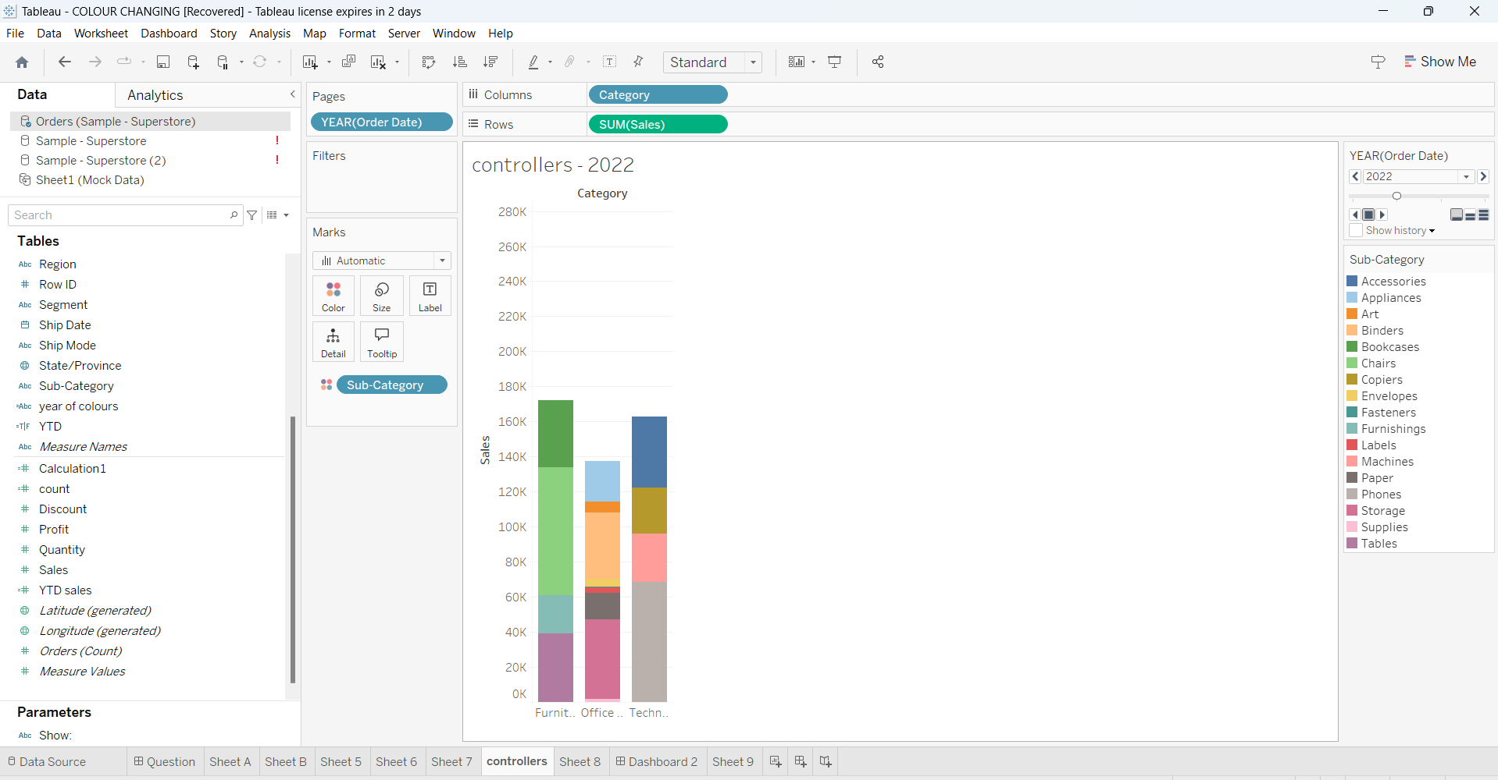

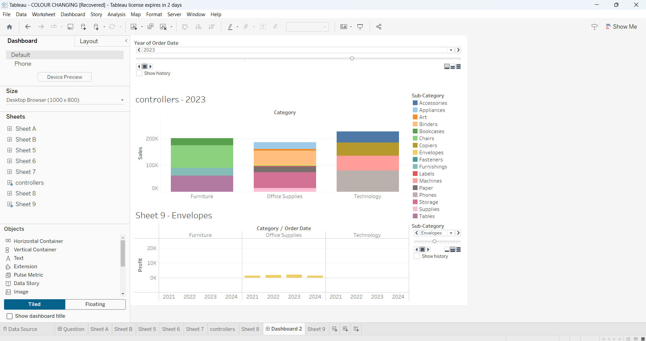

**Parameters: --**

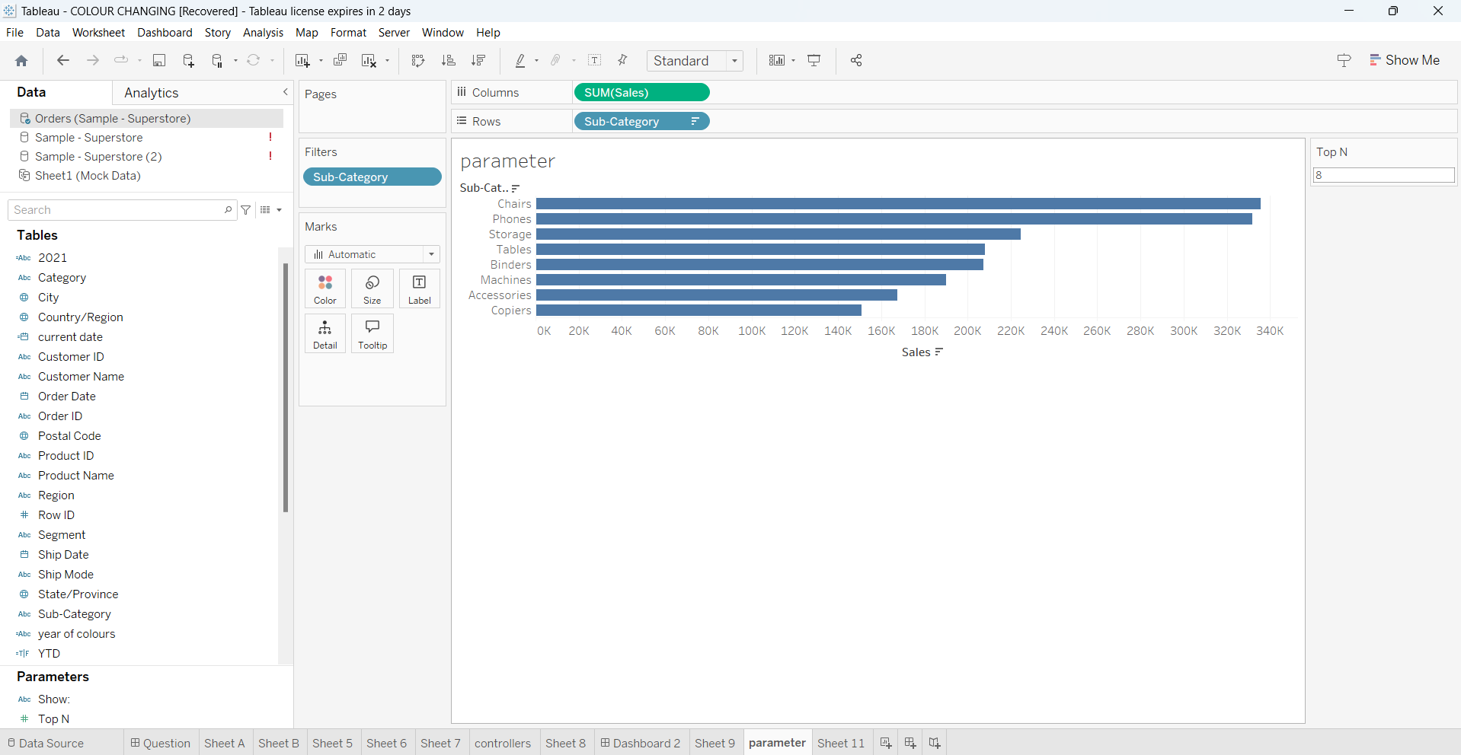

**Parameter with set: --**

